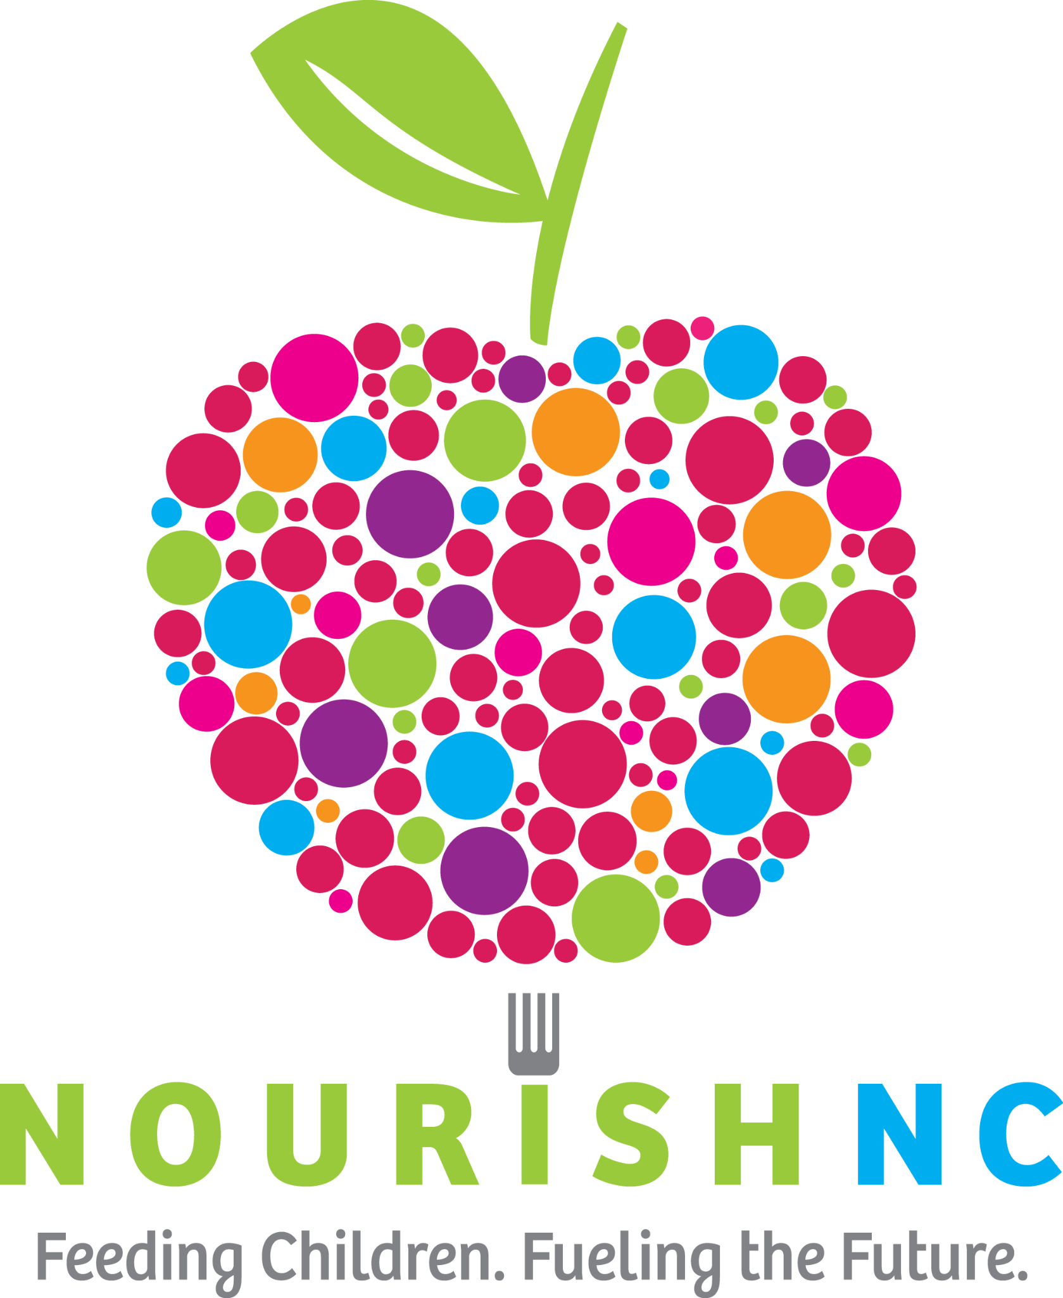
Most Wanted Food Items
Feeding Children. Fueling the Future.
We want to build happy, healthy kids so please avoid junk food and expired food. When possible, choose low salt, lower sugar, and low trans-fat items. Please do not purchase glass items. Take this list with you to make shopping easy!

Fruits & Veggies:
□ Pasta Sauce
□ Jelly
□ Vegetable Cups
□ Canned Vegetables
Reduced sodium or no salt added
□ Citrus Cups
Packaged in 100% juice or water when possible
□ Canned Fruit
□ Individual Juice boxes
100% fruit juice or 100% vegetable juice
□ Applesauce Cups
Unsweetened, low sugar

Grains:
□ Cereal
□ Oatmeal/Granola
□ Clif, Kind or Kashi Bars
<200 calories per bar, 5-8 g sugar, >5g fiber
□ Rice 16 oz.
□ Pasta 16 oz.

Dry Goods:
□ Mac and Cheese
Individual cups or boxes
□ Dried Fruit
□ Go Go Yogurtz
Proteins:
□ Beef Stew
□ Hearty Soups
High protein & lots of veggies when possible
□ Pasta with Meat
Ex. Ravioli with meatballs (cans or microwaveable cups)
□ Peanut Butter or Almond Butter
□ Chicken or Tuna
Cans or Flavored Pouches, packed in water
□ Tuna/Chicken Salad Snack Packets
□ Chili with Beans
□ Black, Pinto, or Refried Beans

Packaged Side Dishes:
□ Knorr Rice/Pasta Sides
□ Compleat Microwavable Meals

4 Highest Need Products
□ Lg Cereal (No multi packs)
□ Compleat Microwavable Meals
□ Large Soup 15 oz.+ (with protein
□ Clif, Kind or Kashi Bars
<200 calories per bar, 5-8 g sugar, >5g fiber

□ Pudding Cups

Tips and Tricks for Successful Food Drives
1) What Do Our Kids Need? See our “Most Wanted” list and ask people to donate these specific items. Quality over quantity is important; we would rather have a smaller food drive that has exactly what we need, than a large food drive with items we cannot use. All items are inspected, sorted, and then donated if they do not fit our needs.
2) Make Plans to Deliver It: By making plans to drop off your collected items, you are freeing up time for us to work on other mission critical things. Our warehouse is located at 3606 Market Street. If you have more than a carload of food, please contact the warehouse to make a drop-off appointment. warehouse@nourishnc.org or 910-465-0995 x 103
3) Avoid Donating Expired Food: Many expired foods are safe for years after the code out date. However, NourishNC does not serve expired food to our kids. Often when people hear “food drive” the first thing they do is grab that can of beans that has been sitting in the back of their cupboard for years. Let’s help serve the NourishNC kids the best.
4) No Junk Food Please: NourishNC does not serve chips, candy, cookies or other unhealthy foods to our kids.
5) What Will You Collect It In: Use small to medium size boxes for heavy items like canned goods. It’s ok to collect items in bags just make sure not to overload them and tie them if they are plastic. This is also why we ask that you please not collect items in glass jars.
6) Be Careful with Incentives or Discounts: When people are hosting events, they often offer discounted admission in exchange for donated canned goods at the door. More times than not, the cash value of the discount was significantly higher than the value of the canned goods-especially when expired and erroneous foods are removed. In some cases, it makes more sense to donate the cash.
7) Fun, Competitive, and Themed Food Drives Work Best: Food drives do well when they are fun, relevant, and competitive. Try themed days centered around our most wanted list (like “Macaroni Monday” or “Tuna Tuesday”) or around your business/business model like stacking cans higher than your building. Competitions between participants with prizes and awards work great too. Not all awards have to cost money. Consider things like making the boss work from a tent for a day or casual day for employees.
8) Host a Food Drive in January or June: NourishNC feeds children all year-round but the majority of food drives tend to be during the holidays (November & December) or when the school year begins (August & September). We would love to see high volume food drives all year!
Thank you so much for helping NourishNC provide nutritious food to hungry children!

